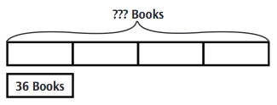

John

Araceli
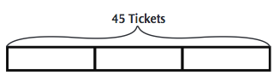
? Tickets

Maria

Javier
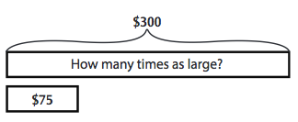

New
?

Used

