Overall Learning Goal:
Theme:
(See district adopted curriculum)

(What do you want the students to learn during this lesson/theme?)

Common Core Standards:
(What common core standard(s) will you address?)

Reference to Preschool Foundations (48-60 months):
(What preschool foundation(s) will you reference?)

Foundations: www.cde.ca.gov/sp/cd/re/documents/preschoollf.pdf
Framework: Volume 1: http://www.cde.ca.gov/sp/cd/re/documents/psframeworkkvol1.pdf
Volume 2: http://www.cde.ca.gov/sp/cd/re/documents/psframeworkvol2.pdf

Resources:

Books | Manipulatives | Music | Technology

 |  | Transitional Kindergarten | Kindergarten
Learning Goal:  (Weekly objective per district adopted curriculum?) | Week 1
 | Week 2
 | Week 3

 | Transitional Kindergarten | Kindergarten
Questioning Techniques:  (What specific questions will you use to engage learners?) | Examples:  What do you think will happen…  What would happen if…..  What is the meaning of…..  How many ways can you….  How would you feel if…..  Why did this occur….  What is another way to….. | Examples:  What do you think will happen…  What would happen if…..  What is the meaning of…..  How many ways can you….  How would you feel if…..  Why did this occur….  What is another way to…..

 | Transitional Kindergarten | Kindergarten
Activities/Centers:
(What specific activities will you use with students to?)

 | Transitional Kindergarten | Kindergarten
Social & Emotional Integration:  (How will you incorporate social and emotional skills into your day?)  For More Information, Refer to: Foundations pgs. 1-45  Framework pgs. 37-96 | Examples with Emphasis on Dramatic Play:  Engage children in independent pretend play  Children take assigned role in acting out a story/finger play  Communicate about pretend play with a peer  Can take a role with other children to create a dramatic play sequence (grocery store, restaurant, post office, etc.)

 | Transitional Kindergarten | Kindergarten
Performance Outcomes:
Formative & Summative
(see district adopted curriculum)

 | Transitional Kindergarten | Kindergarten
Extension Ideas:
(How will you extend this lesson?)

 | Transitional Kindergarten | Kindergarten
Homework:
(What will the students be required to do at home to reinforce learning goal?)

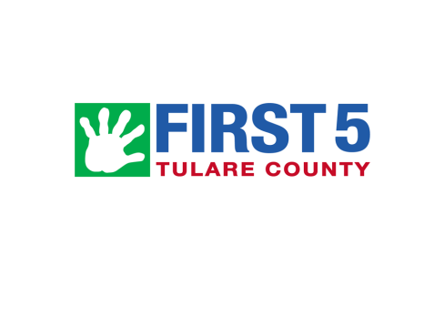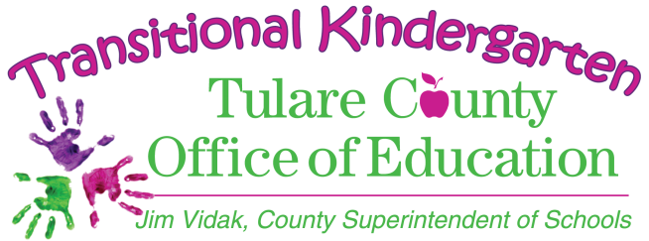Additional Notes/Comments/Ideas:
With support from

